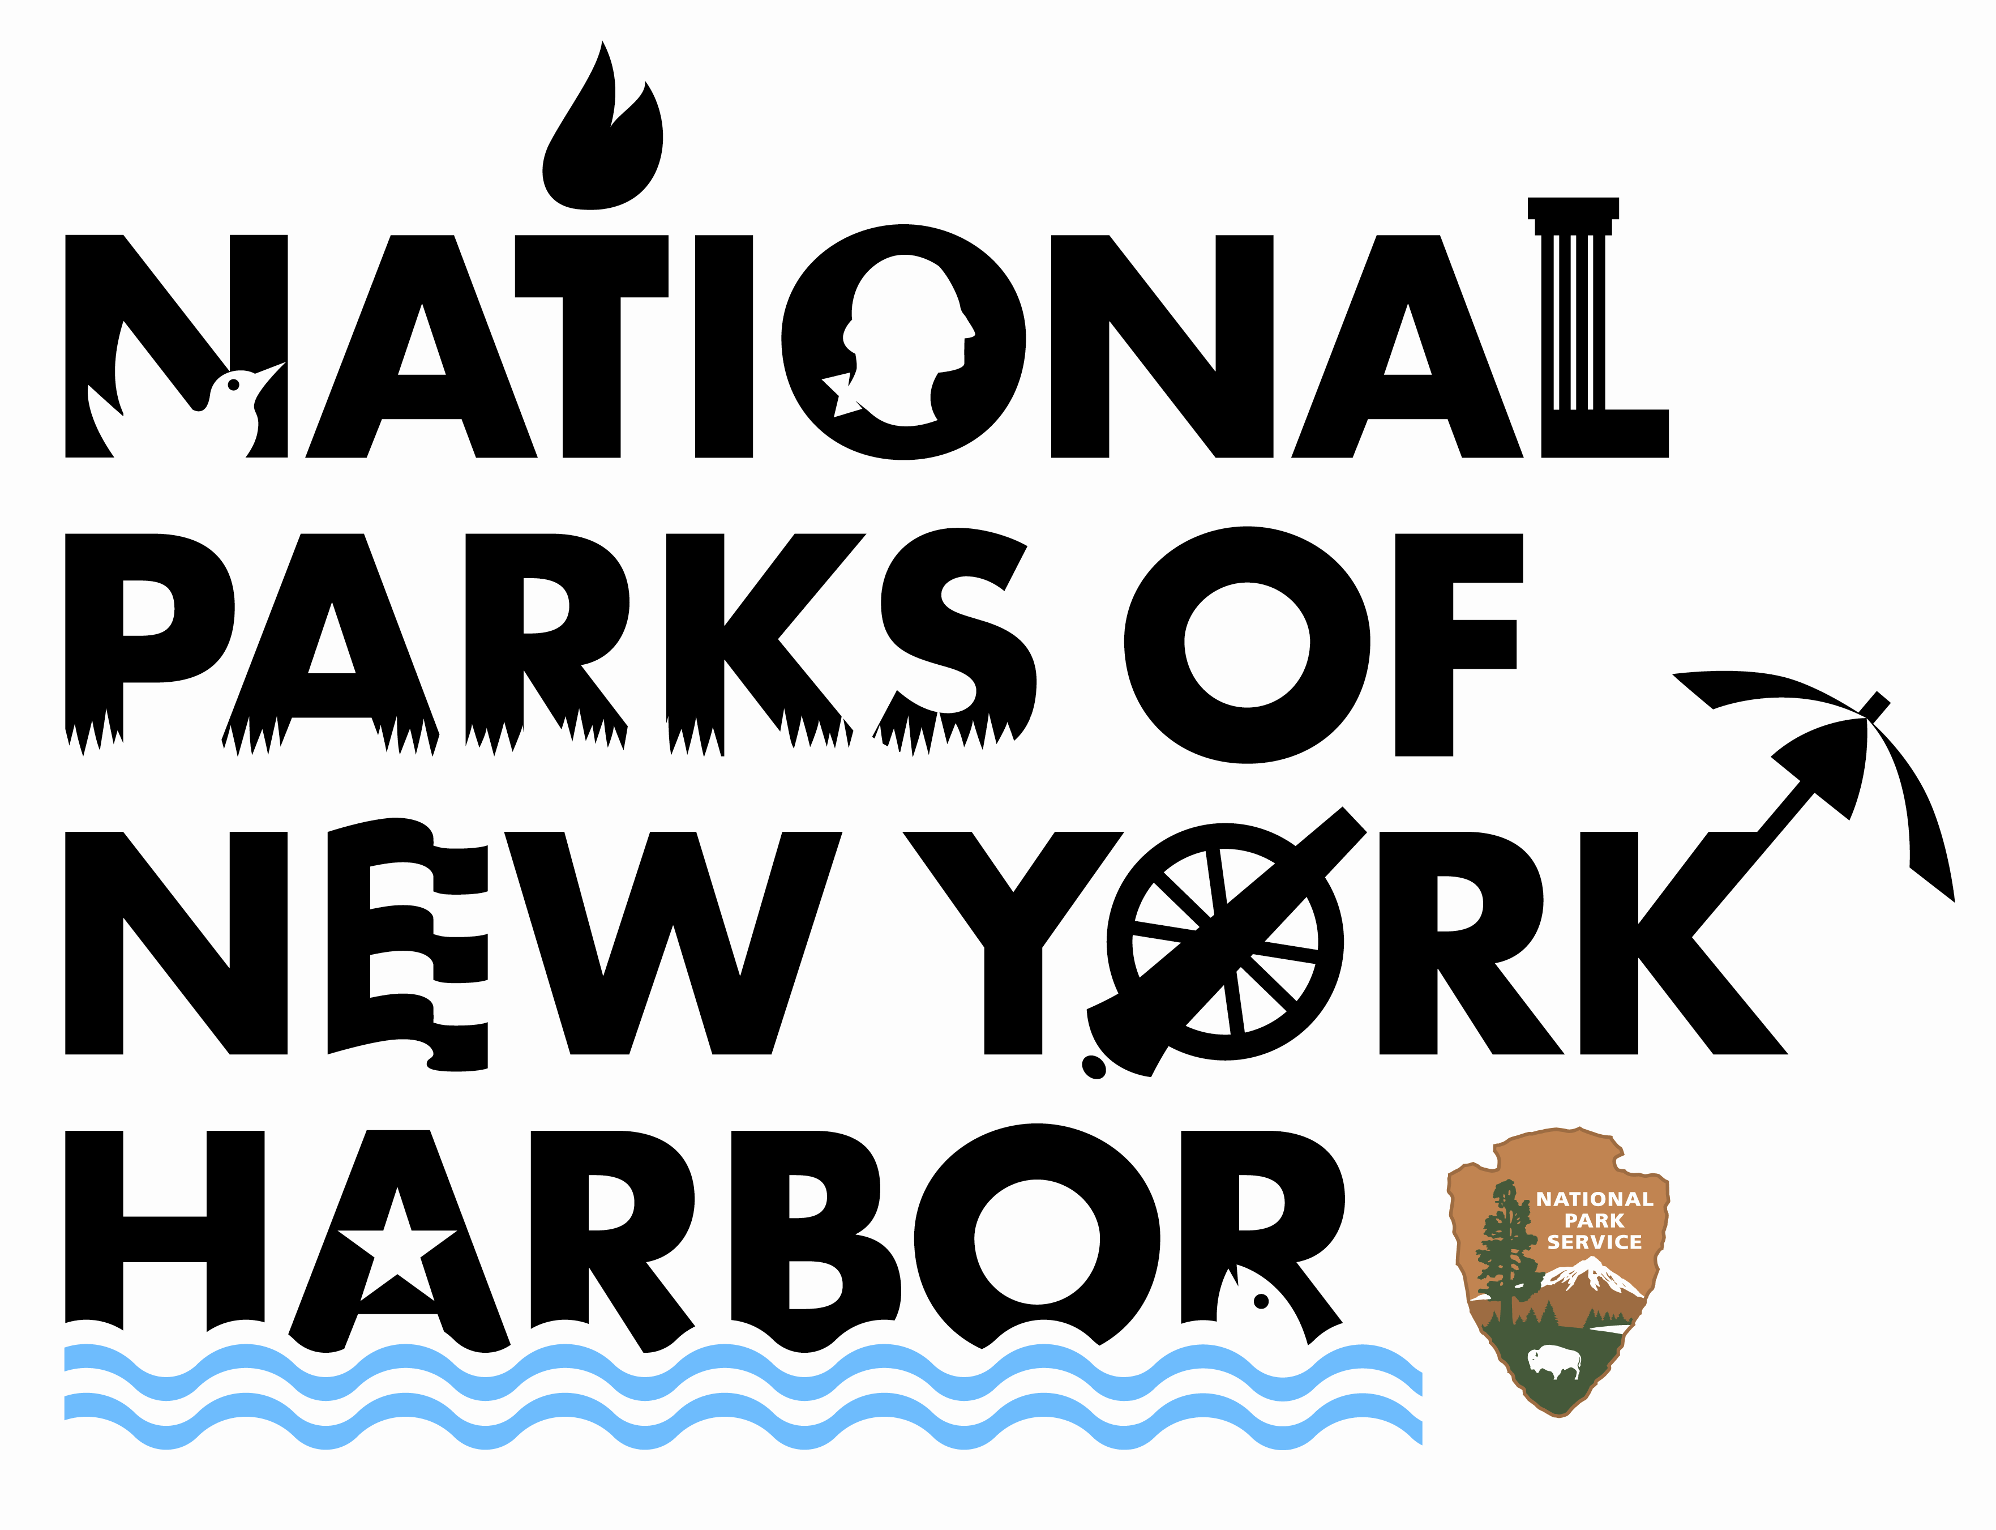
National Park Service
U.S. Department of the Interior
www.nps.gov/npnh

Leasing Policy for Manhattan National Park Service Sites

The National Parks of New York Harbor, an administrative unit of the National Park Service (NPS), permits leasing of several of its historic structures located in the borough of Manhattan and one in Mount Vernon, New York. In accordance with applicable public laws, federal regulations and park special event guidelines, the leasing policy permits certain for-profit and not-for-profit entities to hold events at the parks for a rental fee set by the Fair Market Value of comparable sites in the local area.

Beginning March 1, 2008, NPS will permit corporate entertaining, with the approval of the park Superintendent, at the following sites:

- Federal Hall National Memorial, 26 Wall Street (rotunda, conference room, front steps)
- Theodore Roosevelt Birthplace National Historic Site, 28 East 20th Street (auditorium)
- Castle Clinton National Monument, Battery Park (exterior space on parade ground)
- General Grant National Memorial, Riverside Park (exterior space on steps and plaza)
- St. Paul’s Church National Historic Site, Mount Vernon, NY (church, museum, grounds)

The corporate leasing policy neither permits events during visitor hours nor allows for the use of facilities for fundraising, merchandising or other promotional events. No products, services or tickets may be sold at the site, nor may any products be displayed. Personal events, such as weddings, graduations, or birthdays, are generally not permitted.

Public law allows for short and long term leases of federally owned or administered properties within park boundaries. Rental fees collected are used for infrastructure improvement to the applicable park area, including facility refurbishment, repair and maintenance, and infrastructure projects associated with park resource protection.

For more information about leasing at Federal Hall, Theodore Roosevelt Birthplace or Castle Clinton, please contact Michael Darden at 212-825-6888. For Grant’s Tomb or St. Paul’s Church, please contact Albert Atchison at 212-666-1640.

